Attachment to the Industrial PhD application 2026:

Confirmation of participation in a doctoral project

The three pages of the document are to be sent to the degree-conferring institution for signature and informational purposes.
The Research Council stipulates that applications submitted under the Industrial PhD Scheme must be accompanied by written confirmation that the doctoral project reflects the strategic objectives of, and has been approved by, the Project Owner (company), and that the doctoral project will be completed in a collaborative effort between the Project Owner and the degree-conferring institution.
Please note that the Research Council carries out an administrative review only of applications for funding under this scheme. The degree-conferring institution is responsible for quality assurance of the scientific content of the doctoral project, at the time of admission to a doctoral programme. Doctoral projects financed under this scheme must meet the same requirements for scientific quality set out for other doctoral projects undertaken at the institution, and must follow the institution’s regulations for doctoral degree education, with regard to admissions, implementation and evaluation.
The undersigned confirms that:
- the doctoral project has been planned and will be carried out in cooperation between the Project Owner (company) and the degree-conferring institution.
- the degree-awarding institution confirms that the candidate meets the formal criteria for admission to the institution and is willing to consider admission of the candidate to the relevant doctoral program and will make a professional assessment of the project in that regard.
- the degree-conferring institution and the Project Owner will draw up a collaboration agreement for the doctoral project provided the candidate is admitted to the doctoral programme.
- the degree-conferring institution must ensure that all costs are communicated to the project owner (if applicable: direct and indirect costs).
In addition, the Project Owner (company) confirms the following:
- the doctoral project reflects the strategic objectives of, and has been approved by, decision-making bodies in the company.
- the candidate will be employed by the company for the duration of the project period – also in the event of delays in the doctoral project, and the terms of the employment contract and working conditions are in compliance with Norwegian laws and regulations.
- adequate working hours and internal resources (supervision and funding) have been set aside to carry out the doctoral project.

Further to Page 2: Signature page and Requirements for the collaboration agreement

It is not necessary for all signatures to appear on the same page, but please consolidate all signed pages into a single document and submit it as one attachment.
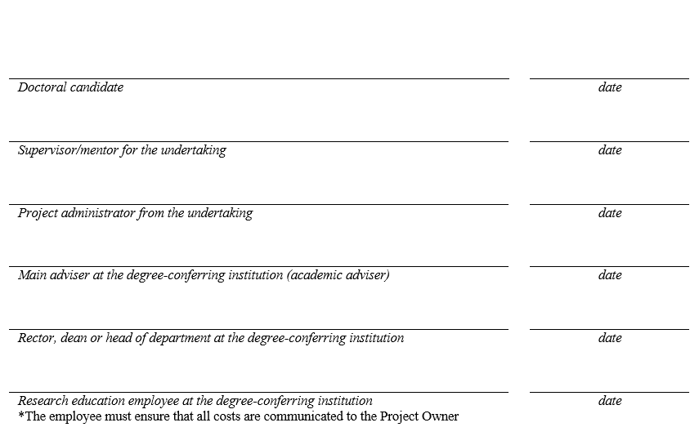

Requirements relating to the collaboration agreement between Project Owner (company) and degree-conferring institution

All entities granted funding under the Industrial PhD Scheme are required to sign a binding collaboration agreement with the degree-conferring institution involved.
Start drawing up the collaboration agreement early on
In our experience it can take time to get the agreement in place. Therefore, the Project Owner (company) needs to initiate cooperation with the degree-conferring institution well before the grant application is to be submitted to the Research Council. The Project Owner may submit an application before the candidate has been admitted to the doctoral degree programme and a final collaboration agreement is in place. The Research Council will be able to process the application and may provide a funding pledge before these documents have been finalised, but will not sign the contract with the Project Owner before the collaboration agreement with the degree-conferring institution is signed and confirmation of admission to a doctoral programme has been received.
The collaboration agreement must at minimum include the following:
- the collaboration agreement is to apply for the entire project period. The project period is to be specified in the text of the agreement
- the ownership of results and issues pertaining to intellectual property rights must be adequately clarified
- the parties are to regulate the ownership and user rights of project results that have been produced by several parties in a collaborative effort. This must be regulated in a manner that ensures that the companies taking part in the consortium do not receive indirect state aid from participating research organisations. The regulation of ownership and user rights must therefore be in accordance with the EFTA Surveillance Authority’s guidelines for state aid for research and development and innovation Section 28 (c) or (d)
- the names, roles and employers of the supervisors from the degree-conferring institution and the company are to be specified
- the agreement must not prevent the candidate from publishing the results of his/her research and presenting them in his/her dissertation. This is to be specified in the agreement
- It must be specified that the candidate is to spend at least one year at a degree-conferring institution and at least one year at the Project Owner (company). The time may be distributed in a manner that is most advantageous for the project
- requirements relating to the work duties on the part of the doctoral candidate must be clarified. This item may also be incorporated into a separate employment agreement between the candidate and the company. In the case of four-year projects, the site where the candidate is to carry out his or her work duties must be specified
- project funding and the distribution of project costs for each partner participating in the doctoral project must be provided
An admissions agreement may satisfy the above items
All doctoral degree candidates must sign an admissions agreement with the degree-conferring institution. Admissions agreements often comprise three sections (A, B, and C) where section C addresses cooperation with external parties. This agreement will in many cases include elements related to requirements under the Industrial PhD Scheme. Any items not included in the above list must be added to the agreement.
The collaboration agreement must be signed at the proper level of authorisation
The agreement is to be signed by an individual with the formal authority to commit the degree-conferring institution at the departmental or faculty-head level. The academic adviser will generally not be authorised to sign the agreement unless he/she also has a key management position at the departmental or faculty level.
For the Project Owner (company), the project administrator is expected to have the authority required. The project administrator must be authorised to sign on behalf of the company, and to enter into a binding agreement with the Research Council.
Signing the contract between the Project Owner (company) and the Research Council
When the collaboration agreement with the degree-conferring institution (and any other partners) has been drawn up and signed, the Project Owner (company) is to upload it as an attachment to the contract with the Research Council. The contract will be published on “My RCN Web”. A copy of the documentation confirming admissions to a doctoral programme (i.e. a formal letter from the degree-conferring institution) must also be forwarded to the Research Council. This letter is to be sent to the case officer as an attachment to an email. The contract enters into force after the confirmation of admissions and the signed contract, including the signed collaboration agreement, are in place.

